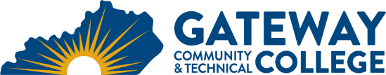
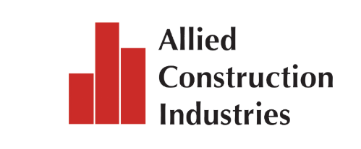

For Immediate Release: April 24, 2026
Contacts: Phil Dischar (Gateway) phillip.dischar@kctcs.edu
Shayna Neverman (TradesNKY) snevermann@emailstrategic.com
Monica Edwards (ACI) medwards@aci-construction.org
Skill UP Career Fair connects over a thousand Northern Kentucky students with in-demand careers at Gateway
Florence, Ky. – Over one thousand Northern Kentucky middle school students explored experiential exhibits representing career opportunities in the essential trades at the skill UP Regional Career Fair, hosted last week at Gateway Community & Technical College’s Boone Campus.
The large-scale, interactive event introduced area students to high-demand careers in the skilled trades through real-world demonstrations and direct engagement with local industry professionals.
Hosted in partnership with TradesNKY, Allied Construction Industries (ACI), with support from the Spirit of Construction Foundation and BE NKY, the event highlighted the critical role of early career exposure in building the region’s future workforce.
Throughout the day, students rotated through immersive exhibits spanning many industries such as construction, advanced manufacturing, engineering, logistics, public safety, energy systems, and cybersecurity. Hands-on stations allowed students to try tools, interact with emerging technologies, and learn directly from skilled professionals currently working in the field.
"Skill Up wasn't just an event, it was a spark,” said Sara Bray, board member at TradesNKY. “From the moment the students walked off the bus, you could see curiosity turn into confidence as students leaned in, asked questions, tried new skills, and discovered paths they had never imagined. What made it powerful wasn't just the learning, but the connection of industry professionals pouring into these kids and walking away just as inspired. That's how you build a future workforce.”
“We are proud to bring education and industry together in a way that is engaging and impactful for students,” said Dr. Fernado Figueroa, Gateway President. “Events like skill UP help students see that rewarding, high-skill careers are both attainable and available right here in their communities.”

As workforce demand continues to rise, initiatives like skill UP play a vital role in closing awareness gaps and inspiring the next generation to pursue the high-paying, in-demand career pathways in their communities.
“Allied Construction Industries developed this event in partnership with TradesNKY at Gateway to provide young people with line of sight and access to rewarding careers in the skilled trades. Additionally, with 500-member companies, ACI is keenly aware of the need to be laser-focused on building a strong pipeline of talent for the region’s employers. Creating this event lets us deliver on both these fronts,” said Jordan Vogel, Executive Director, Allied Construction Industries.
Event Highlights:
- 1,150 middle school students from across Northern Kentucky participated
- 43 regional employers provided hands-on demonstrations
- Interactive career exploration across 20+ trade sectors
- Direct engagement between students and industry professionals
Photos from the event show students participating in demonstrations, engaging with exhibitors, and discovering new career interests: Skill UP Career Fair Photo Album_Gateway 4.16.26
For more information about skill UP, visit skilluptrades.org

# # #
Founded in 1929, ACI is a not-for-profit trade association that represents both union and open-shop employers, including general contractors, subcontractors, architects, engineers, developers, suppliers, and service providers. Together, we represent the full ecosystem that builds and sustains our region’s commercial landscape. ACI-web.com
Gateway is Northern Kentucky’s only public, two-year comprehensive community and technical college. Gateway is accredited by the Southern Association of Colleges and Schools Commission on Colleges (SACSCOC) to award associate degrees. Questions about the accreditation of Gateway may be directed in writing at 1866 Southern Lane, Decatur, GA 30033-4097, by calling (404) 679-4500, or visiting SACSCOC’s website (www.sacscoc.org).For more information, call 855-346-4282. For more news and updates visit Gateway News Archives.

